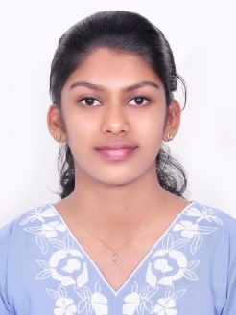ANJALI BABY 

CSD Intern

Email ID: 2406765@cognizant.com

Mobile: +917510348105

Address: Sree Narayana Swamy Ladies PG, Netaji Street, Navalur, Chennai.

LinkedIn: www.linkedin.com/in/anjalibaby963

**CAREER OBJECTIVE**

Looking forward to associating myself with an organization, where there is an opportunity to share, contribute and upgrade my knowledge for the development of self and organization served.

**WORK EXPERIENCE**



**CSD Intern | April 2025 – Present**

Currently undergoing training program on ADM .Net ASP FSE where I’m learning C#, SQL, ASP .NET Core, Entity Framework Core, Bootstrap, Git, JQuery, HTML and CSS, programming courses, gaining strong core and technical knowledge in these courses.

**ACADEMIC QUALIFICATION**

* **University College of Engineering, Thodupuzha.**

B Tech, Computer Science and Engineering | 2021 – 2025 | CGPA – 8.11

* **St. Joseph’s Girls HSS, Meppadi.**

Plus Two | 2021 | 96%

* **Mount Tabor English School, Meppadi.**

Class 10th | 2019 | 92%

**PROFESSIONAL SKILLS**

* Software skills known: Working knowledge in Visual Studio Community.
* Programming skills known: Basics of SQL, Python, C#.
* Adapting to any environment or culture.
* Ability of willingness to learn new things.
* Ability to work independently or as a part of a team.
* Hard worker and has the ability to motivate myself and others.
* Good at oral and written communication

**PROJECT WORK**

* **E-Commerce website**

Developed a **Bookmart E-commerce Website** using **.NET MVC** to facilitate online book sales. This full-stack project encompasses inventory management, shopping cart functionality, and efficient order processing, showcasing proficiency in web application development and database integration.

**WORKSHOPS & CERTIFICATIONS**

* Programming in Python by SWAYAM.
* Workshop in Machine Learning by NIT, Calicut.
* Workshop in Android App Development by NIT, Calicut

**PERSONAL DETAILS**

* Languages known : English, Malayalam, Hindi.
* Domain Interests : Programming, Testing and validating.
* Hobbies : Travelling.